- Volume 1 | Issue 1  Spring 2021 | The Dirt.
What’s New | Welcome to KSM Landscape and Maintenance’s Brand New Newsletter!  Brighten Your Space with Flowering Plants  Flowers are a great way to quickly brighten up any outdoor space. There are many options to choose from depending on whether you want to change up your look from year to year. Annuals only last for the one season, some flowers you can harvest seeds from like Marigolds. Marigolds also deter pests so are a great addition to your garden. Perennials come back year after year and are a more permanent fixture to your yard. Make sure you scout the area of your yard you want to add these plants to so that you are selecting a plant that will do well in that specific area, making sure to let shaded plants have access to shade and full sun plants get lots of sunlight.  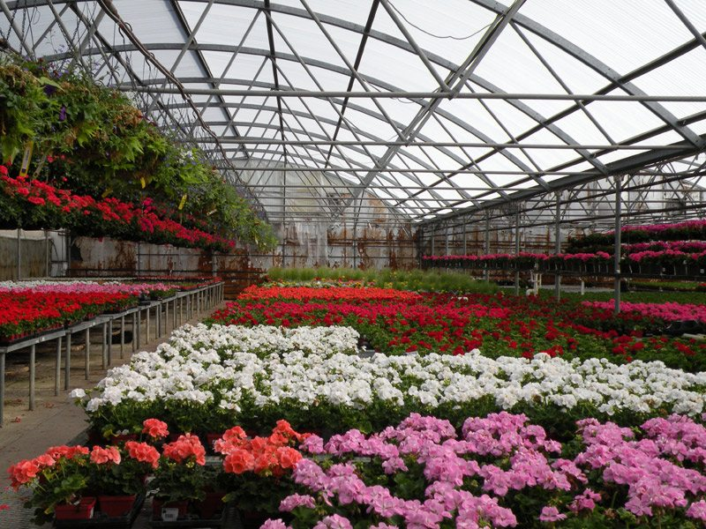  Did you know? We can help you choose perennials for your home and offer installation services.
Spring Planting Tip | If you’ve lived in Colorado for a few years, you may know well by now, we don’t recommend planting flowers or gardens until after Mother’s Day Weekend. We can still get all manners of snow, hail and other types of storms, weather here can turn on a dime in the spring. Seasoned gardeners keep “started” plants safe indoors until the weather is a bit more consistent.  Changes Here at KSM  What’s In a Name?  In case you didn’t know the name history, KSM stands for Kyle, Stephanie Mikel. Kyle has been running the company for several years now, so many of you have worked with him personally. This year it was finally time for Stephanie to take the leap and join the team! She comes to us with over 10 years’ operations experience. She is looking forward to assisting with communications, supporting the scheduling of projects and being able to take care of a lot of the back of house items so Kyle can spend more time with each of you! She is also a licensed mortgage loan officer and can offer cash-out refinancing or Home Equity Lines of Credit for large residential projects to qualifying individuals (NMLS #2075691).  Contact Us  www.ksmlandscape.com  720-490-8607 | Stephanie@ksmlandscape.com

